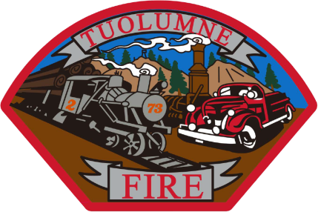
Tuolumne Fire District
18690 Main Street
Tuolumne, CA 95379

November 2025 Department Report

- November 4th Met with ISO field rep for 2025 review.
- November 6th Completed commercial inspections for 2025
- November 11th On duty crew attended Veterans Day Memorial celebration.
- November 11th Monthly Board meeting.
- November 13th Attended Chief’s meeting on Teams.
- November 18th Had a meeting with CSDA rep at the station.
- November 17th Barton Overhead door installed new door safety closure edge.
- November 24th Opened Amazon account with CSDA discount program.
- November 29th Ordered metal shelves for PPE storage project.
- November 30th Monthly station safety inspection done.

Please contact me with any questions or concerns.
Respectfully,

Jeff Santi

Fire Chief

