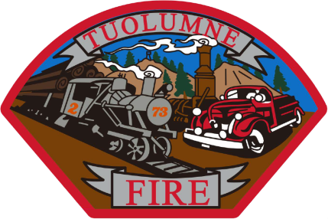
Tuolumne Fire District
18690 Main Street
Tuolumne, CA 95379

April 2026 Department Report

- April 2nd Attended TCU pre-fire season meeting with all cooperators at station 81.
- April 5th Quality control January-March ESO incident reports.
- April 10th Replaced a bad interior light switch in station dorm.
- April 13th Attended a training class for Tablet Command at Sonora City Fire.
- April 14th Monthly Board meeting.
- April 15th Renewed the District’s SAM registration renewal.
- April 16th Diagnosed a leaking fuel injector on E-732. Continuing the repair work.
- April 20th Purchased parts from Interstate Truck Center and picked up from Stockton for E-732.
- April 21st Resealed all 6 injectors with OEM seal kits in E-732. Starts and runs well. Back in service.
- April 21st Received our new ISO rating that improved to a 02/2x from a 03/3X.
- April 27th Attended career day at Sonora City Fire for testing and recruiting new Columbia College graduates.
- April 29th Station review and risk control meeting with our SDRMA representative at the fire station.
- April 30th Monthly station inspection completed.

Please contact me with any questions or concerns.
Respectfully,

Jeff Santi

Fire Chief

