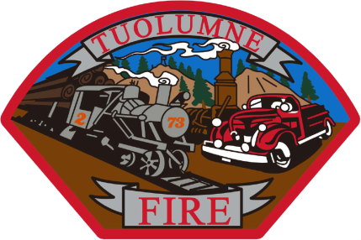

**Tuolumne Fire District**

18690 Main Street

Tuolumne, CA 95379

June 2025 Department Report

* June 2nd Started the annual RT-130 wild land refresher training.
* June 6th On duty crew did safety standby for Summerville High graduation fireworks.
* June 7th Annual hose testing completed.
* June 13th All needed personnel signed up with Active 911 for call alerts with CAD paging program ending with phone carriers.
* June 13th Annual hydrant maintenance completed.
* June 18th Meeting with strategic planning committee and Tuolumne Band of Me Wuk Indians.
* June 19th DOT 90 day inspections completed on apparatus.
* June 19-22 Assisted with the Tuolumne Lumber Jubilee and safety stand by.
* June 24th On duty crew did a fire prevention event at Tuolumne County Library.
* June 25th On duty crew on E-732 and E-733 staffed with additional personnel participated with the Cal Fire Mt Havalia fuel break vegetation management burn.

Please contact me with any questions or concerns.

Respectfully,

Jeff Santi

Fire Chief