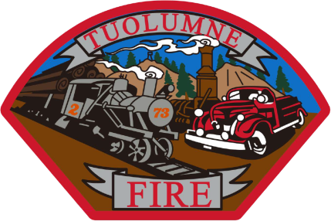
Tuolumne Fire District
18690 Main Street
Tuolumne, CA 95379

December 2025 Department Report

- December 4th-7th Major clean up and PPE project completed.
- December 9th Monthly Board meeting.
- December 11th Barton Overhead door installed new pneumatic door edge on 2nd door.
- December 12th Participated in the annual Tuolumne Christmas parade.
- December 17th Ordered (4) Toyo LT265/70R17 tires for C730 pick up from Doherty Tire $1225.15
- December 17th Ordered (6) Hercules Ironman I-208 11R22.5 tires of E-732 from Doherty Tire $2671.12
- December 22nd DOT 90 day inspections completed on the fire apparatus.
- December 22nd New tires installed on C730 pick up at Doherty Tire.
- December 22nd New tires installed on E-732 at Doherty tire.
- December 29th Filed past years documents into storage.
- December 30th Quality controlled all December incident reports.
- December 31st Monthly station inspection completed.

Please contact me with any questions or concerns.
Respectfully,

Jeff Santi

Fire Chief

