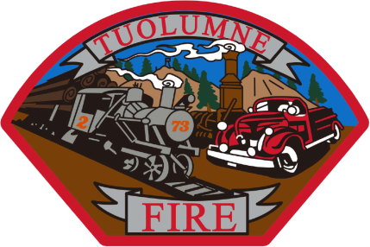

**Tuolumne Fire District**

18690 Main Street

Tuolumne, CA 95379

April 2025 Department Report

* April 1st We have had 4 Intern prospects do a ride a long from Columbia College Academy.
* April 4th Plugged in a computer with mechanic George Danicourt to see how new engine is running in E-732.
* April 7th On duty crew assisted with EMS skills testing at station 81 for Fire/BOC.
* April 8th  I attended the TCU/TFCD cooperators meeting for 2025 wild land season.
* April 8th On duty crew assisted with EMS skills testing at station 81 for Fire/BOC.
* April 9th Ordered a new battery for EMS suction unit.
* April 9th On duty crew assisted with EMS skills testing at station 81 for Fire/BOC.
* April 10th On duty crew assisted with EMS skills testing at station 81 for Fire/BOC.
* April 16th On duty crew attended School Bus roll over training at Summerville High School.
* April 24th On duty crew did a career presentation at Summerville high school.
* April 30th Annual ladder testing was done at the Standard Cal Fire Station with Ross Ladder Service.

Please contact me with any questions or concerns.

Respectfully,

Jeff Santi

Fire Chief