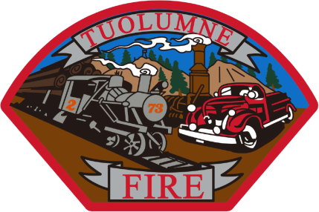

**Tuolumne Fire District**

18690 Main Street

Tuolumne, CA 95379

November Department Report

* November 5th Attended a Tuolumne County Training Officers meeting at station 81.
* November 6th Commercial inspections ongoing.
* November 10th E-732 first at scene at a Structure/vegetation fire on Skyfarm Dr.
* November 11th Diesel fuel was found in coolant system on E-732- Contacted mechanic OOS.
* November 14th On duty crew attended the VFW dinner at the Memorial Hall.
* November 15th Warranty work was approved for George Danicourt to fix E-732.
* November 18th Commercial inspections completed for 2024.
* November 18th HMP was accepted by CAL OES and will be added into the County HMP and sent off to FEMA.
* November 19th On duty crew attended awards ceremony at Black Oak Casino with EMS/Law Enforcement/FF’s.
* November 20th Started to diagnose E-732 new engine issue. Found all 6 leaking injector cups leaking.
* November 26th Mechanic is working with Reviva to get parts needed for E-732 repairs.
* November 27th On duty crew attended a Community dinner at the Memorial Hall.
* November 27th Received the FEMA SCBA Grant reimbursement in the amount of $127,337.71

Please contact me with any questions or concerns.

Respectfully,

Jeff Santi

Fire Chief