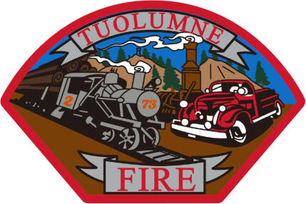
Tuolumne Fire District
18690 Main Street
Tuolumne, CA 95379

May 2026 Department Report

- May 2nd Started scheduling ride- a -longs for potential new intern recruits.
- May 11th Offered conditional Intern positions to four recent CC Fire Academy graduates.
- May 12th On duty crew presented at the Summerville High School career day.
- May 14th Station siren tested through remote activation by Tuolumne County SO & OES.
- May 14th Annual ladder testing completed at the station by Ross Ladder Service.
- May 15th On duty crew did a fire prevention class for Summerville Elementary Head start class.
- May 16th On duty crew did EMS standby for annual Luc’s Run in Tuolumne.
- May 19th Received $12,000 from CSFA/ BAER grant to offset cost of hiring and PPE for new firefighters.
- May 21st On duty crew participated in a County Active Shooter drill at the Tuolumne Resilience Center.
- May 26th New hire packets delivered to Tuolumne County HR for the four new interns.
- May 26th Started annual hose testing for 2026.
- May 27th Received evaluation from SDRMA on risk control inspection at the station.
- May 28th Attended Chief’s meeting virtually on Teams.
- May 30th On duty crew attended and participated in VFW Memorial Day celebration Carter Cemetery.
- May 30th Monthly station inspection completed.

Please contact me with any questions or concerns.
Respectfully,

Jeff Santi

Fire Chief

